|  |  |
| --- | --- |
| **Name:** | **Dhuware Chaitanya Rakesh** |
| **Roll Number:** | **20IM10009** |

**1.Aim of the experiment:**

* **STUDIES ON RECTIFIERS AND POWER SUPPLY**

**2.Tools used:**

* **LT SPICE**
* **COMPONENTS (P-N Junction Diodes, Capacitors, Zener Diode, Resistors, Connecting wires, Oscilloscope, Voltage Source)**

**3.Background knowledge (brief):**

* The block diagram of a typical DC power supply is:

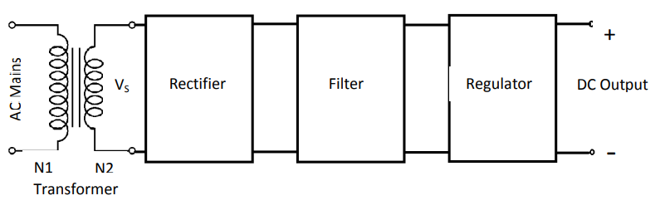

* The transformer is used to step down the AC mains voltage (230V, 50 Hz) to desired voltage level by controlling the turns ratio N2:N1. The secondary voltage, Vs is 230(N2/N1). The transformer also provides electrical isolation to the electronic system from AC mains.
* The rectifier converts the AC voltage to pulsating DC, which is smoothened by filter circuit. The output voltage of the power supply is expected remain constant against variations in the load current or variations in input voltage. This is accomplished by using a suitable voltage regulator
* **Half Wave Rectifier**: This is the simplest rectifier that uses a single diode and a load resistor.
* **Full Wave Rectifier With Center Tapped Transformer**: The circuit consists of a center-tapped transformer, followed by the rectifier formed by two diodes, and finally the load with a capacitor filter . The circuit is designed such that the current through the load is always in the same direction during both the half cycles.
* **Bridge rectifier** is a type of full-wave rectifier that uses four or more diodes in a bridge circuit configuration.
* **Ripple factor** is a measure of effectiveness of a rectifier circuit. It is defined as the ratio of RMS value of the AC component (ripple component) in the output waveform to the DC component in the output waveform.
* **Rectifiers with capacitor filters:** A ‘filter’ (here a simple capacitor) is used to smoothen out the output signal. The capacitor-input filter will charge and discharge such that it fills in the “gaps” between each peak thus, reducing the variations in the output voltage.
* **Zener Diode – Voltage Rectifier:** A Zener Diode is a special kind of diode which permits current to flow in the forward direction as normal, but will also allow it to flow in the reverse direction when the voltage is above the breakdown voltage or ‘zener’ voltage. Zener diodes are designed so that their breakdown voltage is much lower than normal p-n junction diodes.
* **Line Regulation:** In this type of regulation, series resistance and load resistance are fixed, only input voltage is changing. Output voltage remains the same as long as the input voltage is maintained above a minimum value.
* **Load Regulation:** In this type of regulation, series resistance and input voltage are fixed, only load resistance is changing. Output voltage remains the same as long as the load

**4.Circuit (hand drawn/image)**

**WITHOUT CAPACITIVE FILTER**

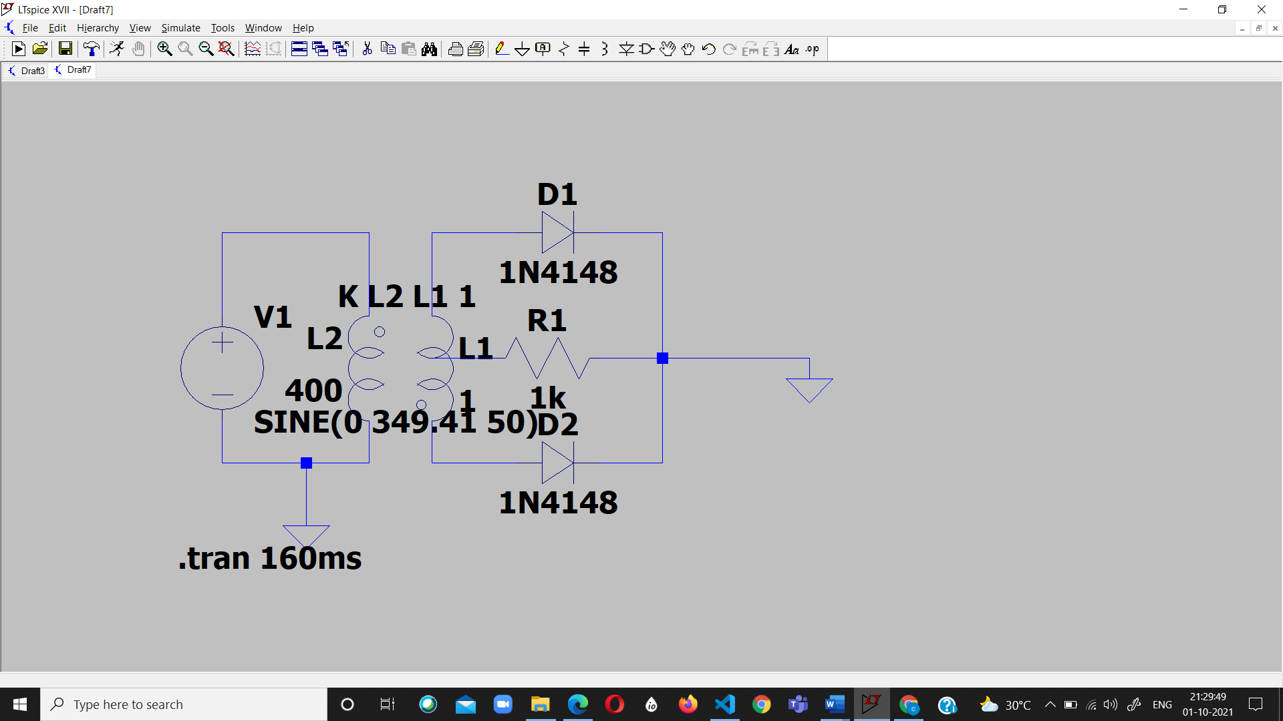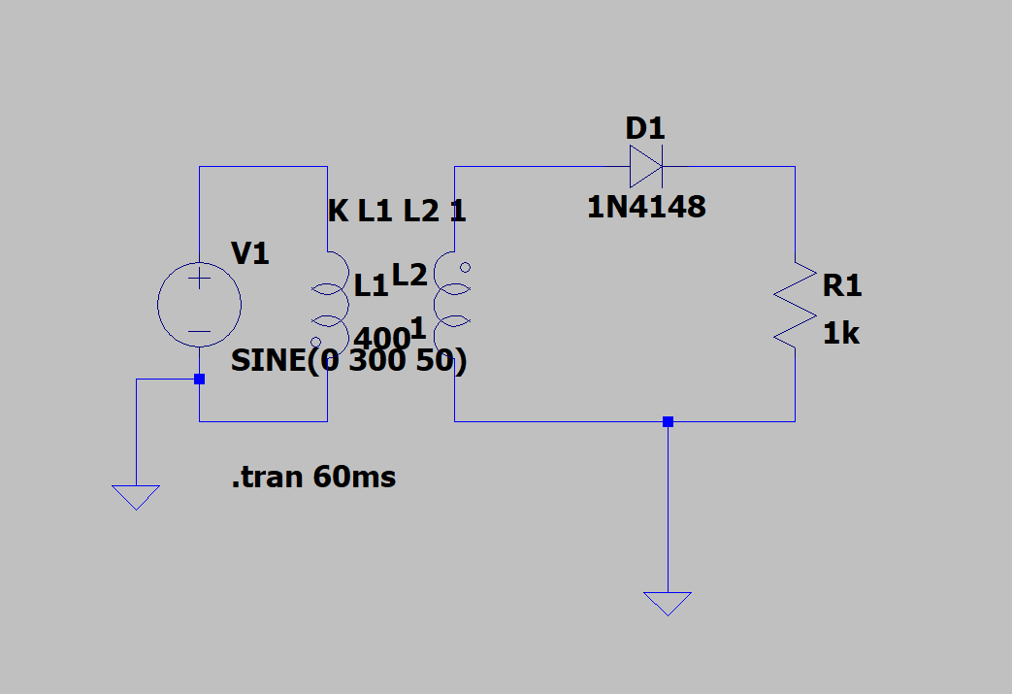

FULL WAVE RECTIFIER(CENTER TAPPED)

HALF WAVE RECTIFIER

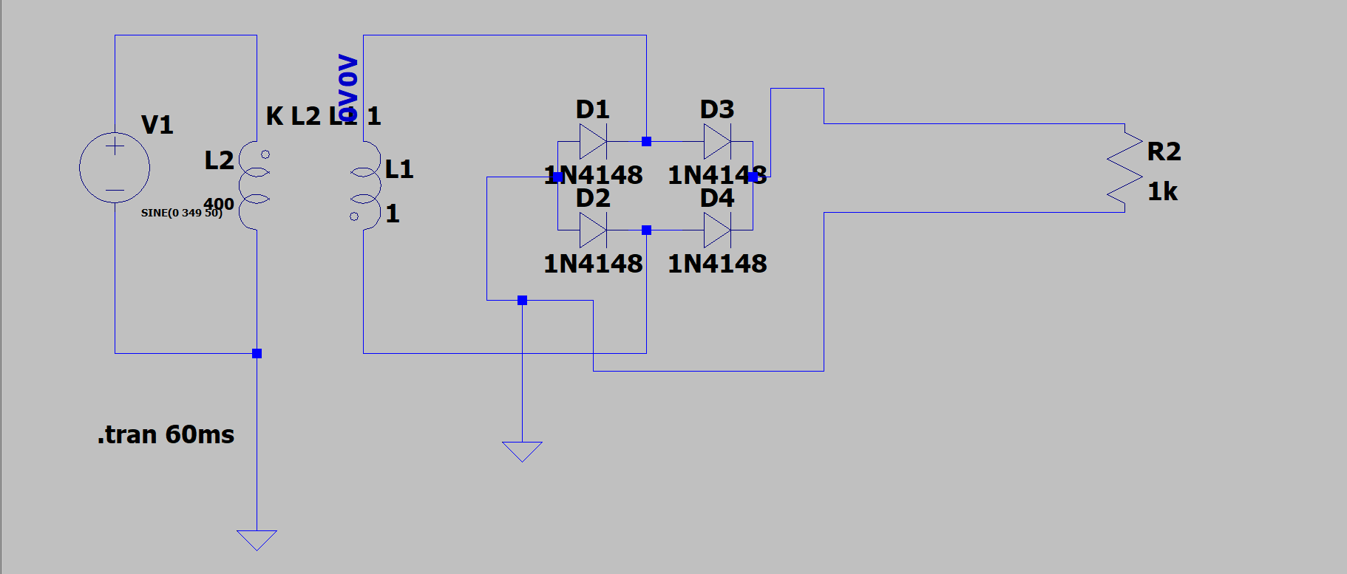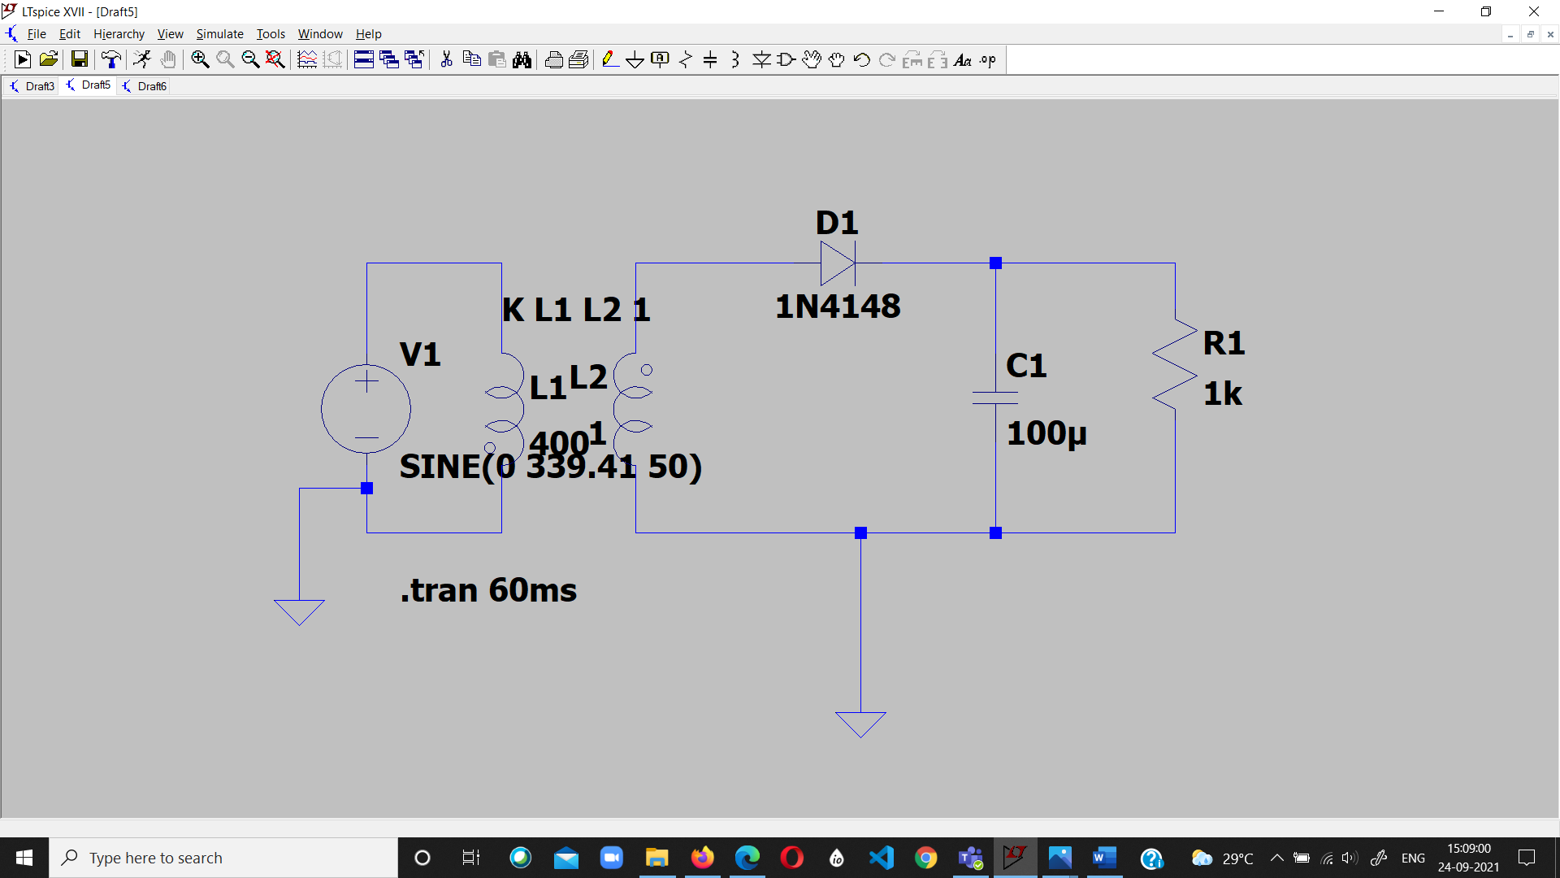

HALF WAVE RECTIFIER

**WITH CAPACITIVE FILTER**

BRIDGE RECTIFIER

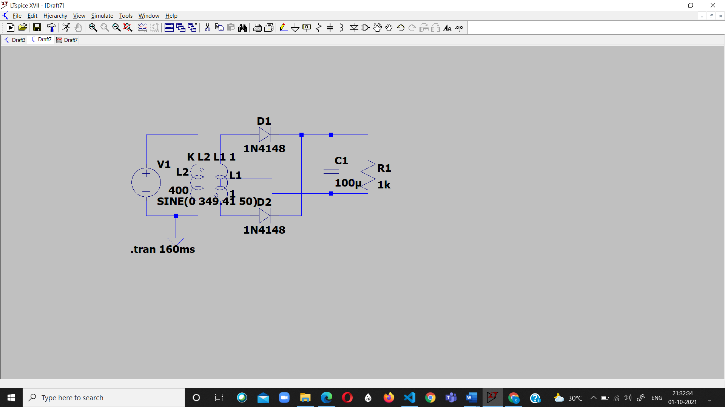

FULL WAVE RECTIFIER

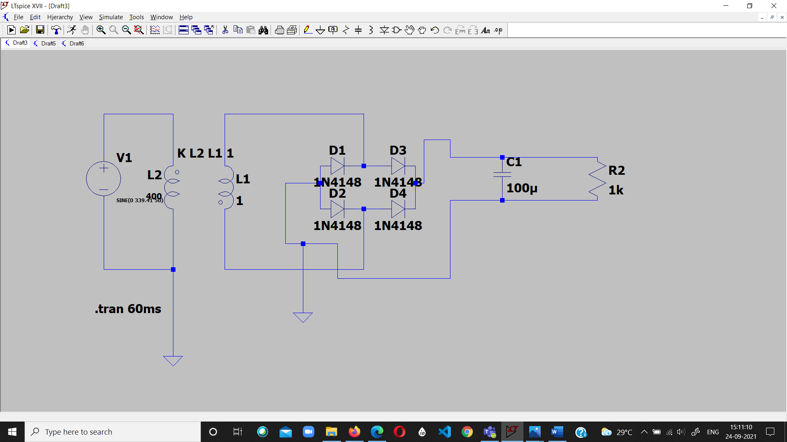

BRIDGE RECTIFIER

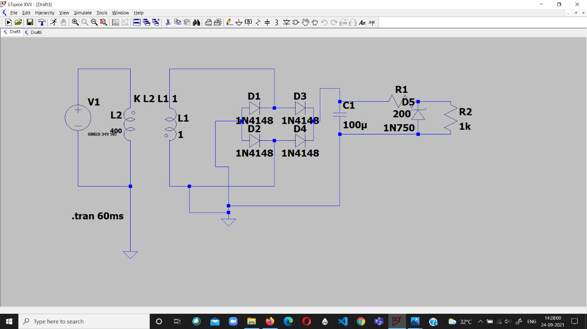

FULL CIRCUIT

**5.Measurement Data (Tabular form)**

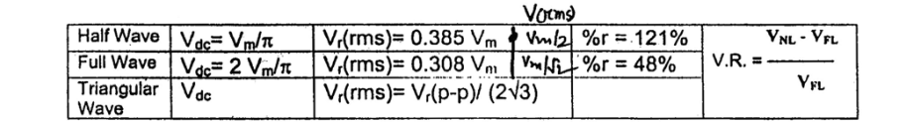

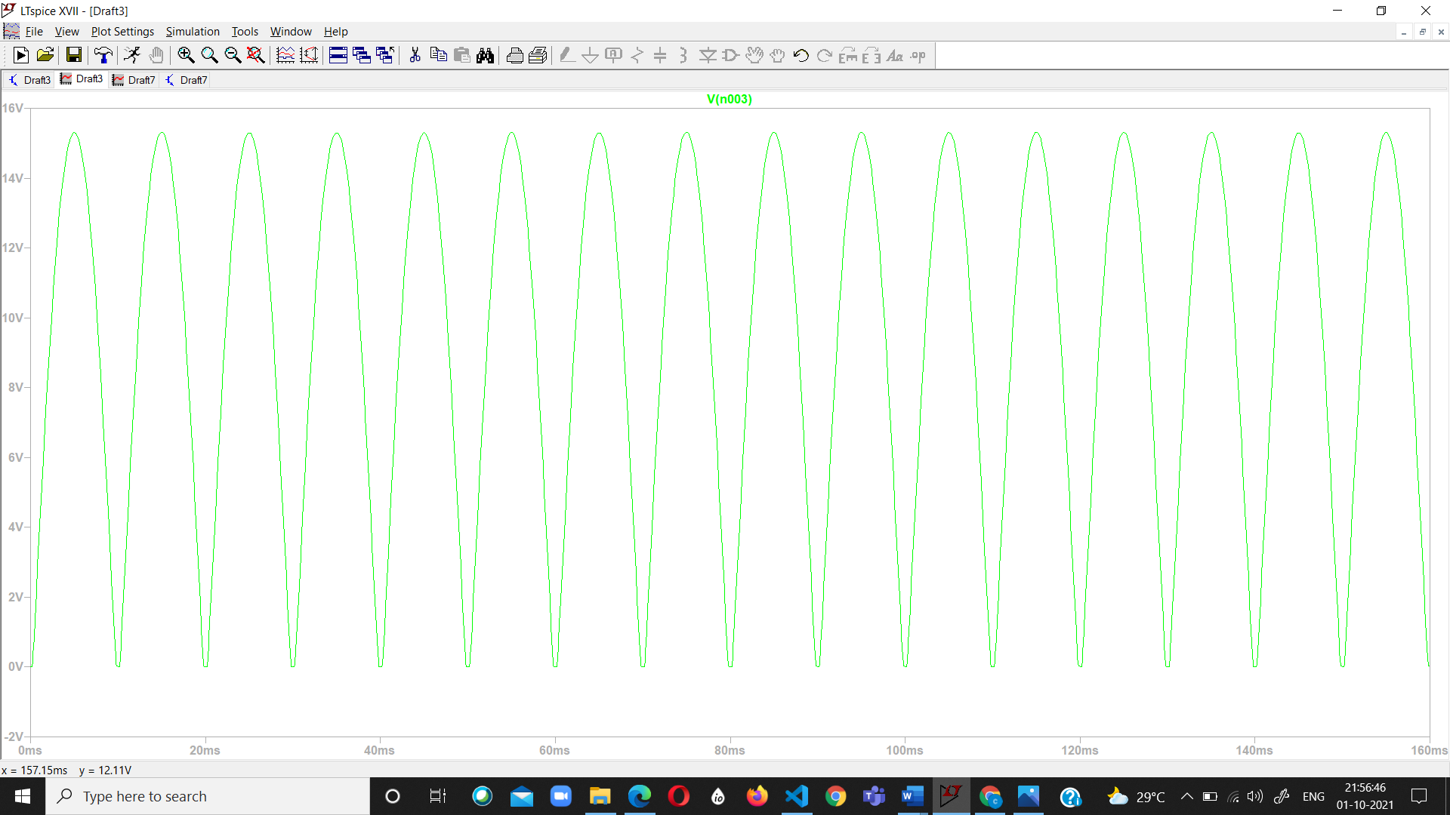**6.Graph (Image)/Screenshots**

FULL WAVE (BOTH) RECTIFIER

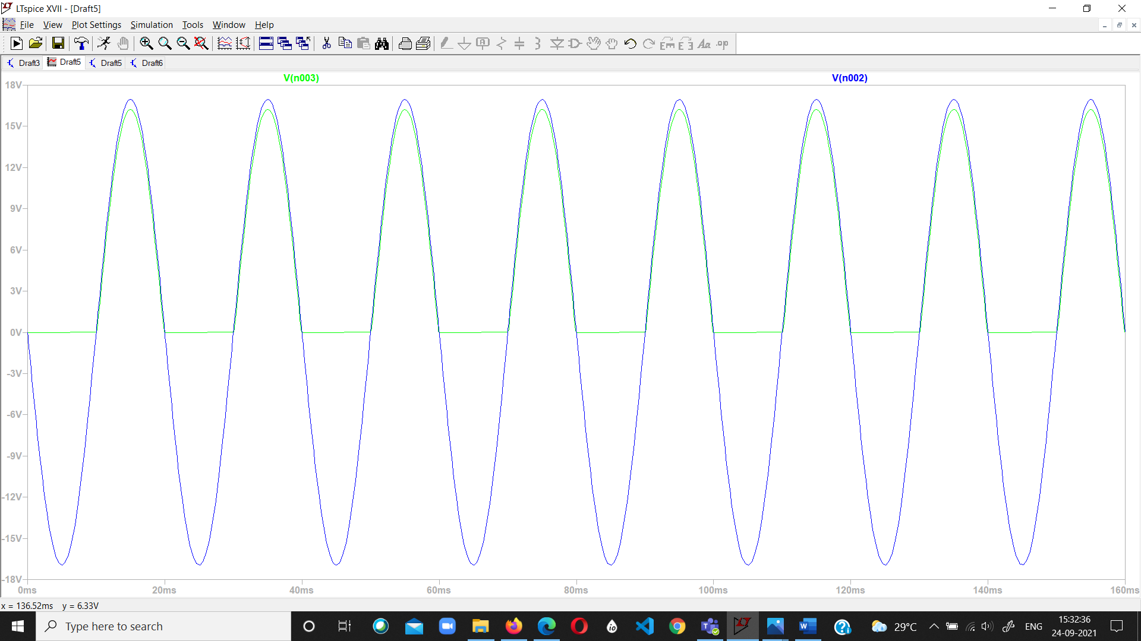

HALF WAVE RECTIFIER

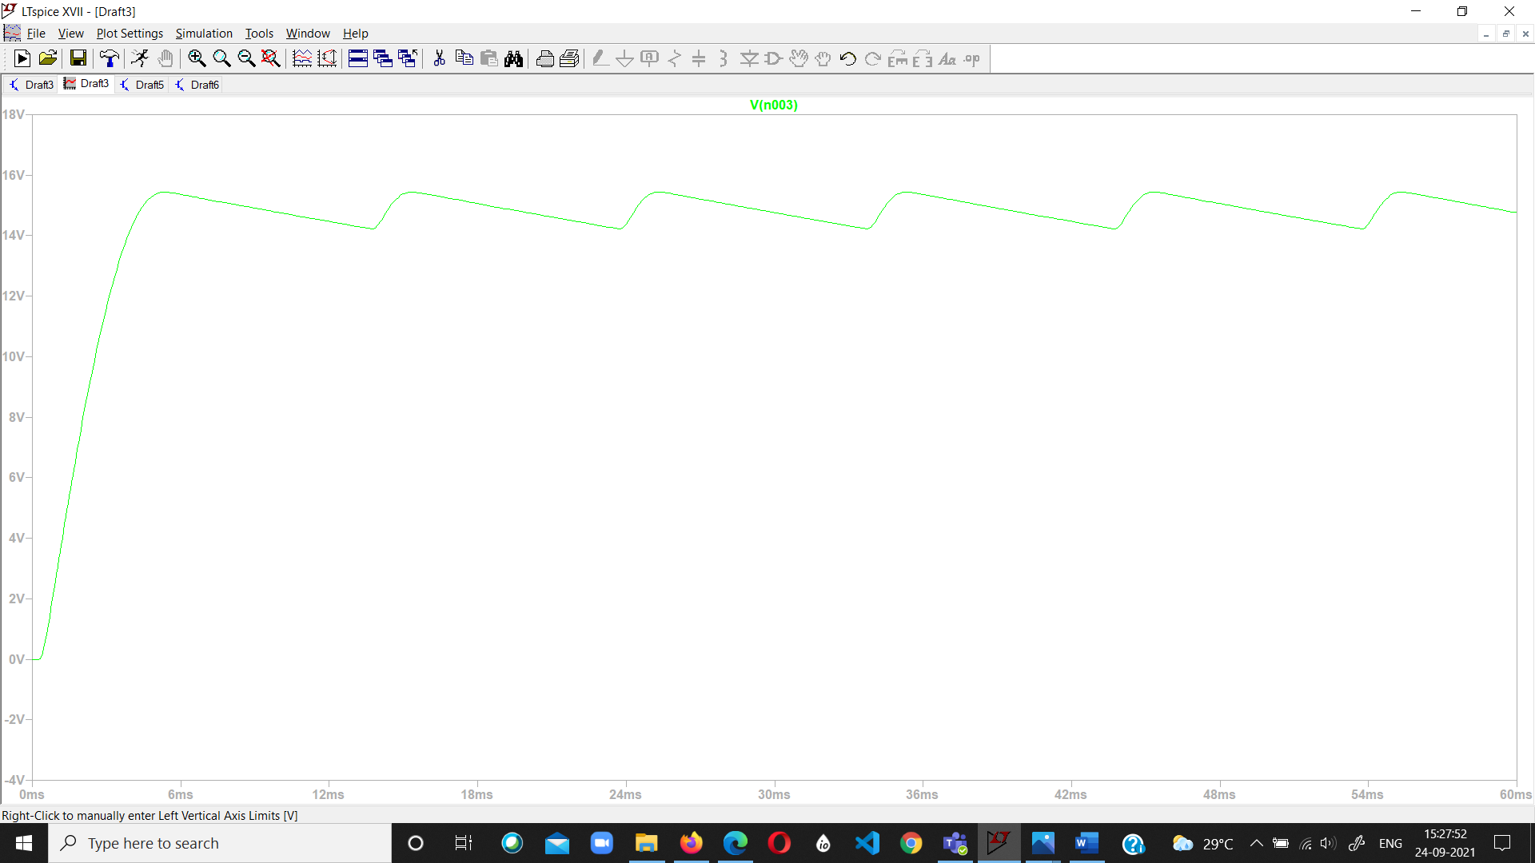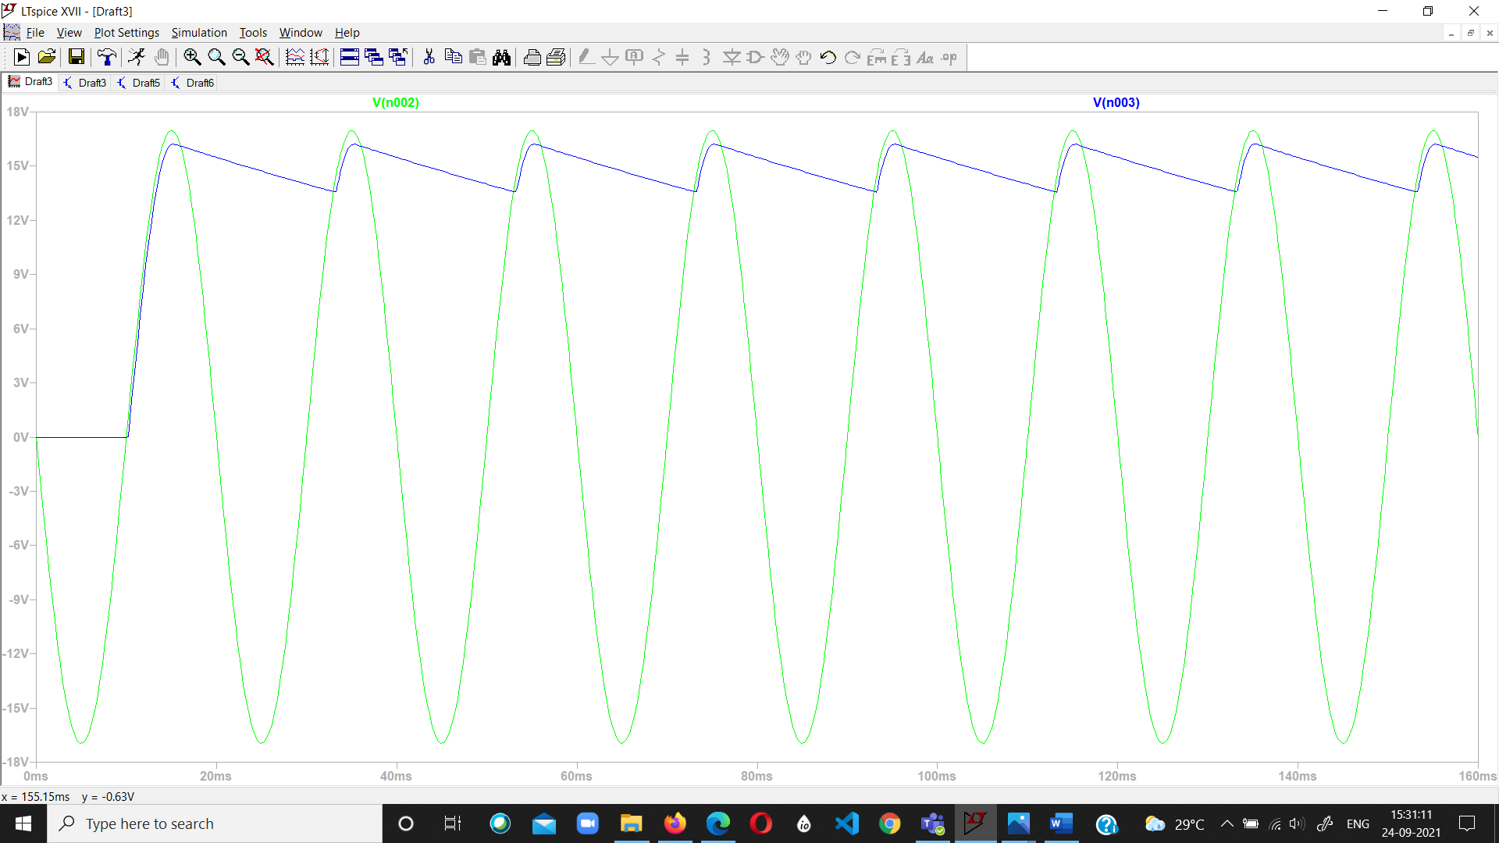

FULL WAVE (BOTH) RECTIFIER

HALF WAVE RECTIFIER

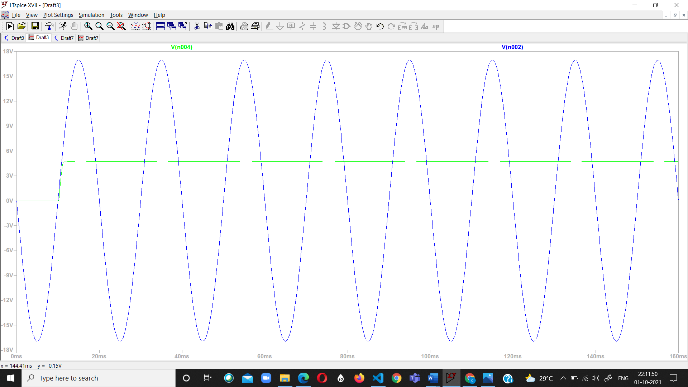

ZENER DIODE OUTPUT

**7.Conclusion**

**RIPPLE FACTOR FOR HALF WAVE RECTIFIER WITHOUT CAPACITOR FILTER**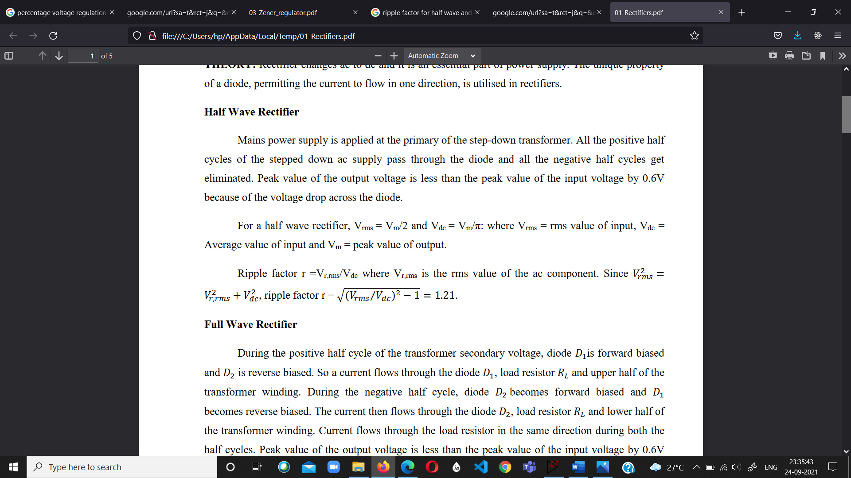

**RIPPLE FACTOR FOR FULL WAVE RECTIFIER WITHOUT CAPACITOR FILTER**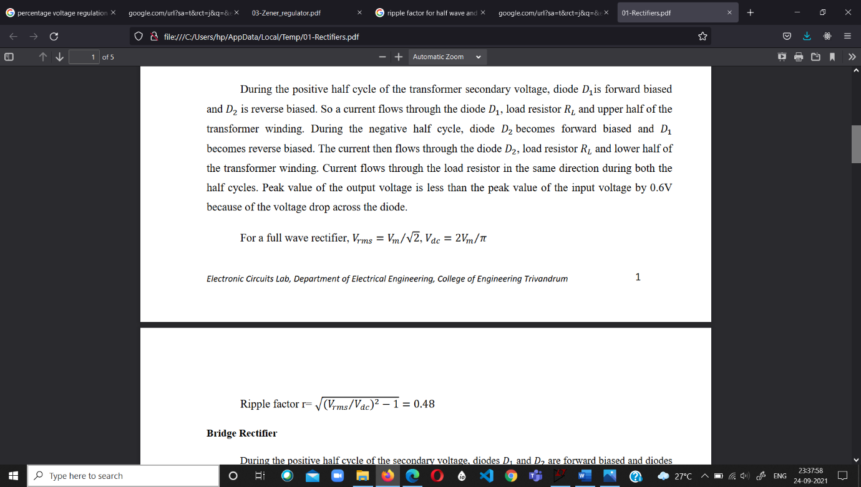

**PERCENTAGE OF VOLTAGE REGULATION :**

Voltage Regulation Efficiency

V(no load) = 4.876

V(load) = 4.54

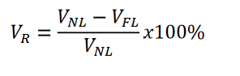

Efficiency = (4.856-4.54)/4.856

= 6.5478 %

**8.Discussions**

* AC to DC conversion is verified from above discussions.
* The Rectifiers Rectifies the input to convert them into pulsating DC
* A simple way to make the output voltage smooth is to connect a filter capacitor across the output terminals though some noise may be present
* Ripple factor is a measure of effectiveness of a rectifier circuit.
* **Zener Diodes** can be used to produce a stabilised voltage output with low ripple under varying load current conditions. By passing a small current through the diode from a voltage source, via a suitable current limiting resistor (RS), the Zener diode will conduct sufficient current to maintain a voltage drop of Vout.
* A simple voltage regulator circuit can be designed using a Zener diode to maintain a constant DC output voltage across the load in spite of variations in the input voltage or changes in the load current.
* The voltage regulation % is verified above with load connected and no load connected.